FOR IMMEDIATE RELEASE 3/21/26
For more information, contact Paul Tukey, 207-252-0869

#FREEDOMWALK2026

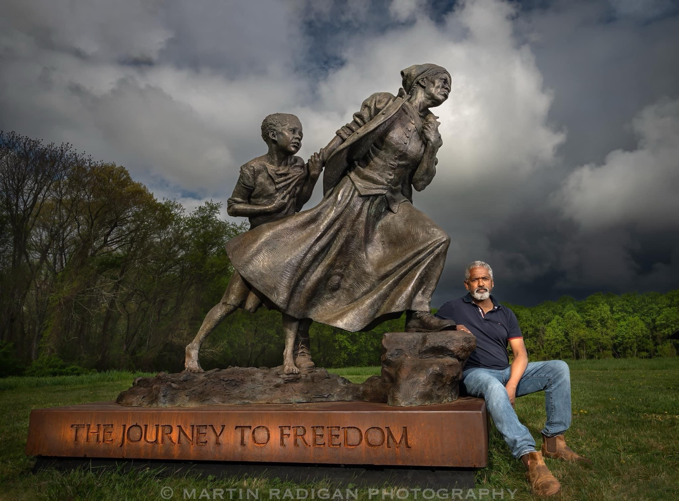30 Years Later, Historian Will Revisit Tubman’s Footsteps

ANTHONY COHEN TO TRAVEL FROM MARYLAND TO CANADA ALONG THE PATH OF THE UNDERGROUND RAILROAD. SUPPORTING RALLY WITH COHEN, HARRIETT TUBMAN SCULPTURE AND LIVE MUSIC AT RIVERWORKS OUTDOOR STAGE, POOLESVILLE, April 30, 6-8pm.

When Anthony Michael Cohen of Germantown, Md., started walking from Maryland to Canada in 1996 in search of traces of Harriett Tubman’s Underground Railroad, he was a 32-year-old graduate student with a backpack and some extra time on his hands. By the time he finished, he wound up on Oprah and discovered his lifelong career.

Announcing plans to make the trek again in 2026, Cohen is now a 62-year-old established historian with a message to the nation on its 250th birthday: “Let’s take pride in all the great moments of our past as we look forward to our collective future.”

The 750-mile pilgrimage, titled #FreedomWalk2026, will begin May 4 at the Sandy Spring Slave Museum. Cohen plans to cross through Pennsylvania, Delaware, New Jersey, and New York before ending in Toronto, Canada on July 4, 2026.

The primary funding mechanism will be per-mile pledge campaign fueled by the general public on his web site: www.menare.org. That grassroots support, according to Cohen, is emblematic of how Tubman herself made the journey to help enslaved Africans escape bondage. Riverworks Art Center will host Cohen, the Harriett Tubman Sculpture, and live music at a rally at the Old Methodist Church on Thursday, Apr 30, 6:00-8:00pm.

Unlike 30 years ago, when he walked mostly alone until Oprah Winfrey and the media and public caught on to his mission, this year Cohen will bring a small team of supporters — and even Harriett Tubman herself, in the form of a 2,200-pound bronze sculpture by North Carolina artist Wesley Wofford.

“The mission of the walk is to bring attention to what Harriett Tubman stood for as an American,” said Cohen, president of the Menare Foundation, a national nonprofit dedicated to the legacy of the Underground Railroad. “Harriett means unwavering courage, liberation, and humanitarianism. The sculpture, titled ‘Journey to Freedom,’ will draw a lot of attention along the way and, frankly, that’s the point. We can all take pride and engage in our shared story.”

As Cohen’s journey progresses from town to town, he plans to stop at key locations daily to highlight landmarks and history. On weekends, the team will co-sponsor Activation Days where the sculpture, towed by truck, will be parked for open viewing and broader engagement.

“The weekly activations will be community gatherings, where thousands of people can join us if they’re inspired,” he said. “We’ll have presentations, service projects, food and music, and community walks where the public can join the journey.”

In addition to the Menare Foundation, #FreedomWalk2026 is supported by several nonprofit organizations include Coming to the Table, Restorative Justice for Oakland Youth, the Washington Revels, and the Potomac Community Foundation.

ABOUT THE MENARE FOUNDATION: The Menare Foundation, Inc. is a nonprofit dedicated to the preservation of the Underground Railroad legacy and to the creation of vibrant experiential programs that use history as a spark for human potential. Menare was founded on the groundbreaking work of historian Anthony Cohen, who embarked on a two-month journey in 1996 to explore an overlooked part of American history—the Underground Railroad—the secret network which thousands of self-liberators traveled to attain their freedom. For more information, go to https://www.menare.org
ABOUT COMING TO THE TABLE: Coming to the Table provides leadership, resources, and a supportive environment for all who wish to acknowledge and heal wounds from racism that is rooted in the United States’ history of slavery. It supports more than 50 local affiliate groups in 18 different states. Coming to the Table is a program of RJOY, Restorative Justice for Oakland Youth (a 501(c)3 organization). For more information, go to https://comingtothetable.org/
ABOUT THE WASHINGTON REVELS: The Washington Revels is a performing arts organization based in Washington, D.C., dedicated to celebrating cultural traditions through music, dance, and storytelling from around the world. One of its ensembles, the Washington Revels Jubilee Voices, performs traditional African American music—including spirituals, shouts, work songs, and protest songs—that trace the history of African Americans from slavery through the Civil Rights era. This group will perform at a kickoff rally planned for downtown Rockville on May 3. www.revelsdc.org
ABOUT THE POTOMAC COMMUNITY FOUNDATION: PCF was formed in 2025 to provide foundational investments in education, workforce development, and historic preservation for the historic African American communities founded after the Civil War in Montgomery County Maryland. www.PotomacCF.org
ABOUT RESTORATIVE JUSTICE FOR OAKLAND YOUTH: Restorative Justice for Oakland Youth is a nonprofit organization that promotes restorative justice practices to address harm, build relationships, and strengthen communities. It works with schools, community groups, and the justice system to help young people resolve conflicts through dialogue, accountability, and healing rather than punishment. www.rjoyoakland.org
ABOUT RIVERWORKS ART CENTER: Rooted in the small town of Poolesville, Riverworks Art Center offers a wealth of arts and culture programs in a restorative rural setting, including art classes, introductory workshops, community roundtables, Storytellers presentations, theater and music classes for children, fine arts exhibitions, outdoor concerts, community festivals, weekly jam sessions, and more.

